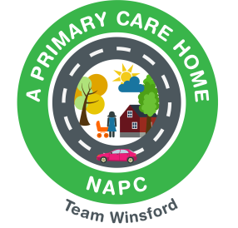
WINSFORD PCN - SOCIAL PRESCRIBING REFERRALS (Age 18+)
High Street Medical Practice - Launceston Close Surgery
Swanlow Medical Centre - Willow Wood Surgery - Weaver Vale Surgery

Referral can include one or more of the following, this however is not an exhaustive list
- Relationship breakdown
- Domestic abuse support
- Bereavement support
- Volunteering opportunities
- Work, education, and training
- Housing advice
- Benefits and financial advice
- Debt advice
- Caring responsibilities
- Support with one or more long term health conditions
- Emotional wellbeing support
- Support with lifestyle changes
- Social isolation- support you to be more socially connected
- Befriending
- Family support services
- Support groups
- Mental health support as a direct result of social factors
The Social Prescribing service is available to all patients aged 18 and over registered at a Winsford GP practice:
YOU can self-refer by contacting your GP surgery

